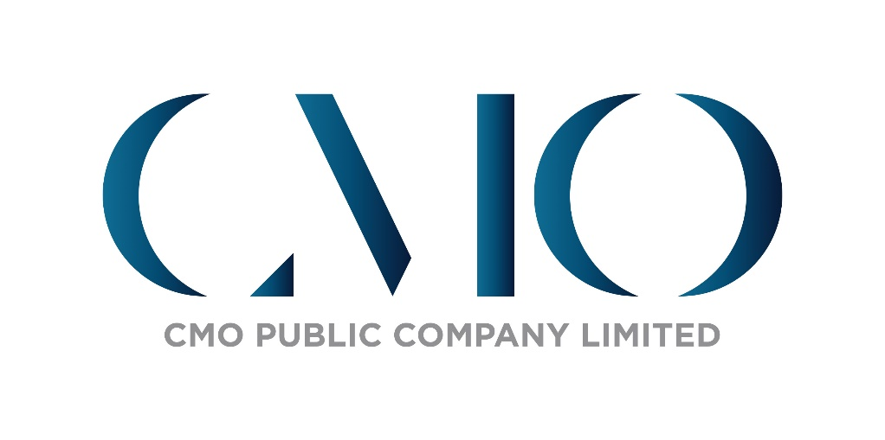

**CMO Public Company Limited**

**Anti - Corruption Policy & Whistle Blowing**

**Anti-Corruption Policies and Guidelines**

Although the Company has not signed a declaration of intent to participate in Thailand’s Private Sector Collective Action Coalition Against Corruption (CAC); However, the Company is committed to conducting business with transparency, honesty, compliance with the law, good corporate governance principles and sustainable development guidelines, focusing on creating a good sense of responsibility towards the economy, society and environment, thus, anti-corruption guidelines have been established in the Supplier Code of Conduct to be used as a guideline for conducting business in accordance with legal requirements and the Company’s Code of Conduct as well as international standards. The Company gives importance to and encourages its business partners to conduct business with transparency and comply with safety, occupational health and environment standards as follows:

1. Integrity: Partners must not practice or tolerate any form of corruption, must not offer gifts, bribes, fees, services, discounts, other privileges or any benefits to employees of the Company including their families to obtain special privileges from the Company, meals, hospitality or small gifts of normal value, which are permitted only on occasions that are appropriate for a holiday, which is not construed or perceived as an obligation.
2. Conflicts of interest: Partners must not be involved in any business, financial or other relationship with the Company's employees that could be seen as having a conflict of interest with the Company. Moreover, the Company's employees are prohibited from working in the positions of executives, directors, employees, agents or consultants of business partners unless consented by the Board of Directors of CMO Public Company Limited. However, business partners must disclose information to the Company and correct all conflicts of interest that occur or may occur in the future.
3. Confidentiality: Partners must not disclose commercial confidential information related to business, financial information or other important secrets of the Company, including customers of the Company to other people or use for the personal benefit of a particular person without permission unless the consent of the Company has been given. If the partner violates causing damage from such actions, it will be the responsibility of all partners.
4. Compliance with laws and safety standards: Partners must provide a safe, hygienic and conducive working environment for effective work and comply with relevant laws or regulations, including requiring safe operational control, accident prevention and potential health effects from operations

**Whistle Blowing**

The Company has designated the internal audit unit to be a whistleblowing agency, including monitoring compliance with the Code of Business Conduct. There are channels for all groups of stakeholders to report clues or find fraud, including the violation of rights or matters that may cause damage to the Company. Notification can be through the internal audit agency via cia.cmogroup@gmail.com for the Company to investigate the facts and carry out the process appropriately and in a timely manner. The Company has a policy to protect and keep the information and identity of the whistleblower strictly confidential.